|  |
| --- |
| Circle Language Spec: Commands |

## Private Objects in a Command Reference in a Diagram

This article demonstrates a situation of command objects.

This article illustrates how private objects in a command reference look in a diagram.

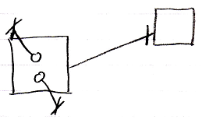

The square on the left is a command reference. Its target definition is indicated with a solid line, which is an object, pointing at the square on the right, which is the target definition. The circles inside the square on the left are the private objects of the command call. The fact, that they are private is displayed with the object line and the cross it ends with indicating, that you can not reference these objects from the outside.

Another possible expression of the private objects is the following:

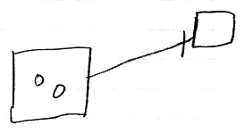

Because public object, parameters, always come with an indication of the parameter passing, you may not need to express the objects’ being private, because it would be obvious: if they do not have a parameter passing, then they are private.

Either of the square could have been replaced by a diamond, making the command symbol executable, rather than dormant.